A

Synopsis

On



**Google Assistant Controlled Home Automation**

Minor Project

For

Partial fulfillment of

Diploma Computer Science & Engineering

Session (2022-23)

Submitted By:

**RITIK DUBEY (203500053)**

**GAUTAM YADAV (203500024)**

Submitted to:

**DEPARTMENT OF COMPUTER SCIENCE & ENGINEERING**

**UNIVERSITY POLYTECHNIC**

**G.L.A UNIVERSITY, MATHURA (U.P.)**

**Abstract**

This Project is a website which would have two sides one would be for faculties and another for the students. On student’s side, students will be able to see all the course structure of the whole course and all the assignments, practices etc. In this project there is authentication will tell the course of student and few things. We will provide the introduction videos those videos will be uploaded by faculty from their portal. On a big level faculty will be able to check the student and evaluate the student’s performance from this website. We are going to use Microsoft SQL Server to store data and ASP .NET with MVC 5 for all the development.

**1 Introduction**

**1.1 Basic Introduction**

A website, it is the most widely used keyword now-a-days with the help of websites we are managing all the things, we are managing institutes, hospitals, banks etc. And there is no any heavy requirement to access a website we only need a web browser which comes with every mobile and desktop.

So, we are developing a Learning Management System from where student can see his/her course structure including all the assignments, test and practice etc. Now-a-days everything is going in online mode so we decided to make an LMS (Learning Management System) benefit of switch any thing online is to save paper works and maintenance etc. An LMS is important because students should be aware about his/her future course and what actually he is going to study in his/her course.

Initially, we’ll provide introduction video of every subject from our website, students will be able to know about that subject what is that subject and what is need of that subject we’ll divide all the subjects year and semester wise. Student of first year would be aware about all his/her final year’s subjects. And after doing this we’ll add practice and assignments and some more features.

**1.2 Objective**

Main objective of this project is to make study easier for students by providing them more resources or students would be aware about their course and subjects of upcoming semesters and years.

**1.3 Scope of the Project**

The future scope for this project can be huge. There are many factors to improve on to make this project more powerful, smart, advanced and to provide information like GFG and Stack Over Flow. For example we can provide a community support for all the students on this website with the help of community students will be able to ask their doubts and share their problems and we can provide theoretical information for example we can provide topic wise videos or some more thigs.

**2 Data Flow Diagram of the Proposed Project**

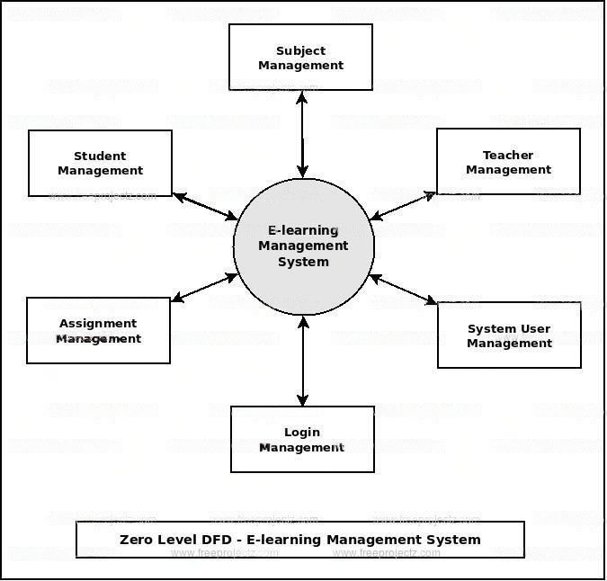

Fig 2. DFD of Project

**3 Hardware and Software to be used**

**3.1 Hardware to be used**

1. **Minimum 2 GB RAM**
2. **Minimum 10 GB space in HDD / SSD**

**3.2 Software to be used**

1. **Visual Studio 2022**
2. **Microsoft SQL Server 2019**
3. **Microsoft SQL Server Management Studio 19**

**4 Gantt chart**

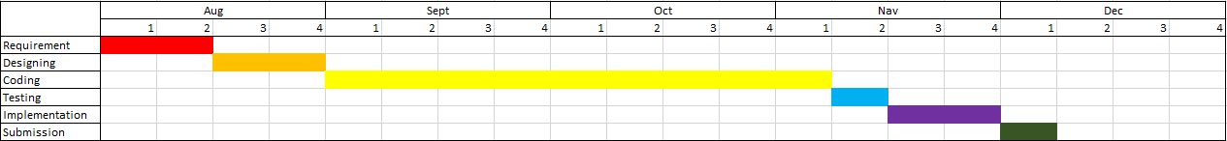

**5 Members of the project and their roles**

* GAUTAM YADAV - Coding, testing, implementation for Student Portal and connecting.
* RITIK DUBEY- Coding, testing, implementation for Faculty Portal

**6 Conclusion**

The aim of this project is to make aware students about their studies and provide them resources properly regarding to their course………………...